When designing a computer system, there are several questions that must be answered before a design
may proceed:
1) What kind of Microprocessor?
2) What speed?
3) How much RAM?
4) How much ROM?
5) What kind of IO?
6) IO Speed?
7) Algorithms?
8) Software support?
9) Real-time?
Most designers make their first mistake by ignoring some (or all) of these questions. In fact, this is the
hardest part of a design!

A Burglar Alarm
The alarm system should have the following characteristics:
1) Able to run for at least 24 hours without AC mains power.
2) Allow interfacing to at least two switch sensors.
3) Must be able to detect if a switch has been tampered with.
4) Must be low cost and have minimal chip count.
5) Produces some kind of irritating siren when a sensor is activated.
6) Has a 4 button keypad that is used to enter a code that enables/disables the alarm.
7) Alarms after 4 incorrect attempts to disable.
8) Mutes the siren after 30 seconds, but remains "tripped" until manually reset.
9) Provides some user indidation of status ("unarmed" or "armed/tripped").
10) Others???

Asynchronous Serial Reception
The transmitter side of a serial link is pretty easy to deal with. Basically a parallel-to-serial convertor with
a little extra logic.
Since transmissions are asynchronous, the receive side is a little more complicated.

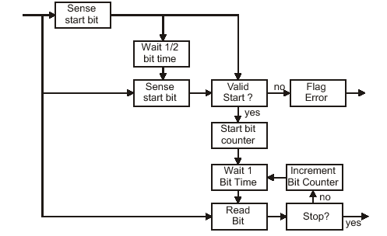

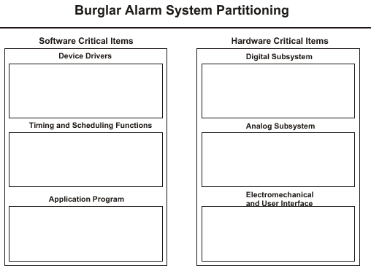
Creating a practical asynchrounous serial link requires adding bits to the serial data stream to aid in
decoding it by the receiver and to aid in verifying correct transmission. This is where start, stop, and
parity bits enter the picture.
Let's consider the transmission of the byte C9 at 4800 baud using 1 start bit, 1 stop bit, and even parity:

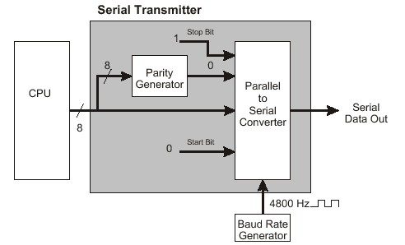
If we looked at this on an oscilloscope we would see something like this on the serial output:
Each bit requires 208.3 ms to transmit. Thus, the entire character (defined as the byte plus the start,
stop, and parity bits) requires 2.292 ms for a total rate of about 436 bytes/s. If we changed to the more
popular 1 start, 1 stop, no parity format our data rate would increase to 480 bytes/s.
This explains a little about why no parity is more popular -- it's faster! (but at what cost?).

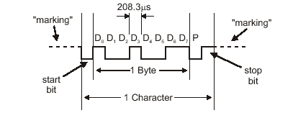
Problems With Synchronization

By sensing the center of a bit, the receiver is a little robust against minor timing inaccuracies between
the transmitter and the receiver. Large inaccuracies, however, are not tolerated!
For example:

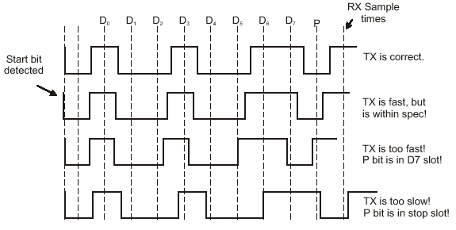

Memory:
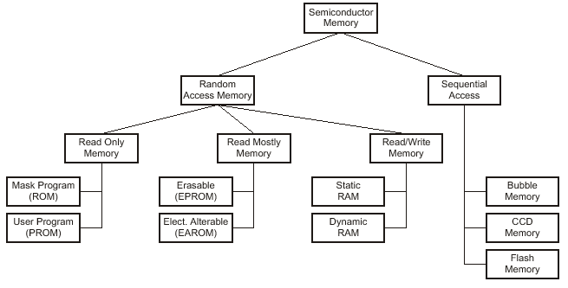

The memory requirements of microprocessor based systems vary widely from tiny systems (like the
microprocessor we used inside the sensor of our advanced burglar alarm) to large systems containing
hundreds of megabytes of semiconductor memory and many gigabytes of rotating disk memory.
The organization of these elements in a computer system is referred to as the computer's memory
system architecture. This architecture is a primary driver behind both the performance and the cost of
the memory system.
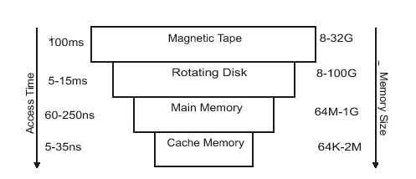

Seven-Segment LED Displays:
The parallel subsystem is often used to drive display devices, including seven-segment LED displays. These are called seven-segment displays because the most basic version of these displays contains seven LED's formed into a figure-eight.

This configuration of seven LED's can be used to represent each of the numbers from 0 to 9, so they are widely used for display purposes. In reality, most 7-segment displays include a decimal point as well, so they are really eight-segment displays:

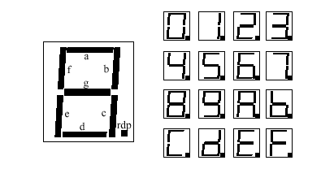
Remember that an LED is lit by applying voltage across it from
anode to cathode. This causes current to flow toward the cathode,
and energy is dissipated inside the diode. In a normal diode, this
energy is given off as heat, but in an LED, this energy is dissipated
(at least partially) as visible light.
Be sure to attach each of the LED's to a current-limiting resistor
(typically 180 ohms), or they will have a very brief but brilliant lifetime. This can also lead to latch-up of the driving device! There are two types of seven-segment displays: common anode and common cathode. In a common anode device, a low-level
voltage at any pin causes the LED segment to be lit, while a high-level voltage reverse biases the diode and results in an unlit segment. In a common cathode device, the opposite is true.

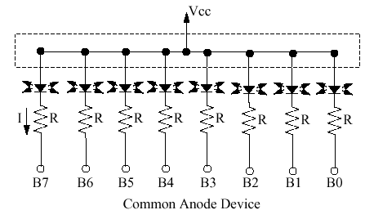

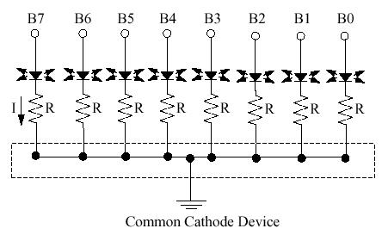

Finally, you can use a hardware decoder chip to convert between
hexadecimal numbers and seven segment codes. Many of these
decoders include current-limiting resistors on the chip, as well as
latch enable pins to allow multiplexing of a port to drive many
LED displays.
In the example shown below, Pins PB0- PB3 carry a hex number,
while pins PB4 and PB5 determine which of the two decoders will
latch this number in. The latch enable is asserted low, and if it is
not asserted, the decoder simply ignores the inputs.

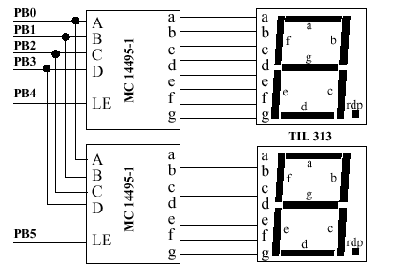
Liquid Crystal Displays (LCD's):
LCD's are much more complicated than LED's, but their superior
performance makes them very popular in today's marketplace. An
LCD involves a liquid suspension of crystals with two electrodes
around it:
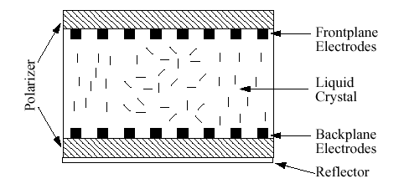
When the electrodes are excited just right, it causes all the crystals
in suspension to line up in the same direction. This allows more
light to pass through the suspension and reach the reflective surface at the back.
Thus, more light is reflected from regions with an applied electric
field. This is known as a reflective LCD, while an absorption LCD
uses reflective crystals and a black background so that regions with
an applied electric field appear darker than regions without a field.

Parallel Input (Keyboard Interfacing)
Interfacing to a keyboard is a very common application for a microcontroller. Whether the keyboard is a full alphanumeric typewriter keyboard or a simple 12-key telephone number pad, the concept is the same: the MCU must be able to reliably sense when a key has been pressed and identify which key was pressed. Typically, this is done using a “matrix” keypad layout. There are a series of horizontal and vertical wires, and pressing a key makes a contact between a particular pair of these wires:

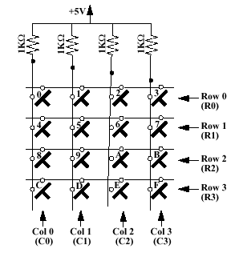
In this case, the MCU will use the horizontal leads for output and
the vertical leads for input (or vice versa). Specifically, it will
drive one of the rows low, and the rest of the rows will be driven
high.
The MCU then reads the values at the inputs to see if one of them
is low. If one is low, the MCU will know that a connection has
been made between the two low-level lines, but if none are low, it will know that no key is pressed on that row. It will then send a different line low to sense for a key press on the next row, and so forth.The figure below shows a schematic of the connection between
the MCU and the keypad:

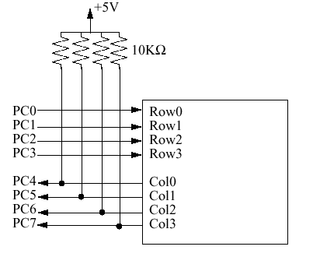
Given this connection, the MCU will know that if pin PC4 goes low when pin PC1 is driven low, then the “4” key has been pressed.
Question: How will the MCU know that the “D” key has been
pressed?
Question: What is the purpose of the resistors in this circuit?
Typically, key identification is done with a software lookup table, which contains the code that will appear at the terminals when each of the 12 or 16 keys is pressed. Port C is especially useful for keypad applications since each of its bits can be configured as either an input or an output. Remember that a keypad involves the contact of two metallic surfaces, and such contact always involves bouncing. It is important to “debounce” the keypad switches, either with special hardware or by building in a software delay to wait until the keypad has stabilized. You will also need to write routines to sense both when a key is pressed and when it has been released.

Consider that you want to drive two 5x7 dot matrix LED displays. Each one has an array of row and column pins, like this:

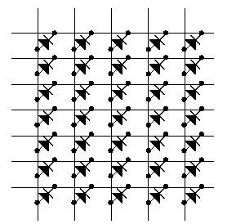
To drive this display, you will need to activate a single column, and light (or turn off) the seven dots in that particular column. You will then light the next column, and so forth. Persistence of vision will cause it to look like all the dots are lit at the same time, but in reality, it is all part of a loop. Also, if you want to interface to several different displays, you might use AND gates to cause the signals to be routed to the
appropriate location. This use of AND gates is shown on the next page, being used to
drive two different 5x7 displays. Driving more displays could be done using a larger decoder, and keeping seven AND gates for each display.

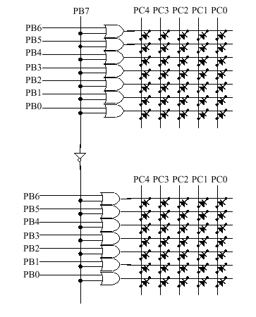

Offset=The minimum analog value.
Span=Difference of maximum and minimum analog values.
Weight=Analog change corresponding to a particular bit changing in the digital number.
Step Size=Span/2 ^{n} , where n is the # of bits in the digital number.
%Resolution=1/2 ^{n} * 100%
analog value=(digital number*step size)+offset
digital number=(analog value-offset)/step size
For example, if the analog range is -5V to +5V, and the digital
range is 8 bits:
offset=-5V
span=5V-(-5V)=10V
step size=10V/2 ⁸ =10V/256=39.1mV
%Resolution=1/256*100%=0.391%

Question: If the analog range is -5V to +10V, and the digital
number is 12 bits, what is the offset, span, step size, and %
Resolution? What will be the digital number that results if an
analog value of -1 volt is applied to the converter?

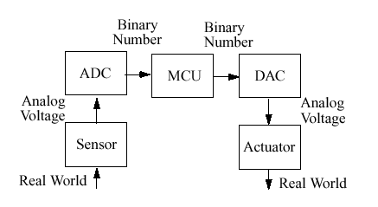
Doing so involves two
steps of conversion, since we must know the details of the sensor output as a function of the measured quantity. A typical sensor output will have the form:
analog number=m*measurement + k
You can determine m and k by measuring the analog output of the sensor at the minimum and maximum measurement values. For example, assume a temperature sensor has a measurement
range of -1°C to +14°C, and the output range is -2.5V to +5.0V.
The sensor is connected to an 8-bit A/D. Determine the offset, span, step size, and the digital number corresponding to 10°C.

Solution:

Offset= -2.5V and -10°C
Span= 5.0V-(-2.5V)=7.5V and 140°C-(-10°C)=150°C
Step Size=7.5V/256=29mV and 150°C/256= 0.59°C
140°C*m+k=5 and -10°C*m+k=-2.5
150°C*m=7.5
m=0.05V/°C, k=-2V
Analog output is (0.05V/C)*10C - 2V =-1.5V
Digital output is (-1.5V-(-2.5V))/0.029V=34.8
Rounded output is 34, which is $22.

Question: Assume a temperature sensor has a measurement range of -20°F to +120°F and the output range is 0V to 10V. If the sensor is connected to a 12-bit ADC, what is the digital number corresponding to 72°F?

1. A/D Converters:
There are several different techniques commonly used to perform A/D conversion. The most common of these are:
Integration:
This technique is commonly used in digital meters. It involves the use of an analog integration circuit to generate the digital signal. It has good accuracy and noise immunity, but is slow.
Flash conversion:
This method uses a lot of hardware to perform
a very rapid conversion. It is good for DSP applications, but can be quite expensive.
Sigma-Delta conversion:
This method uses a digital filter and an oversampling of the analog signal. It groups several single-bit samples together to generate a multi-bit resolution at a slower
sample rate.
Successive approximation:
This is the method used in most microcontrollers, including the HC11. It is important to understand the limitations of this scheme, since they will affect
the accuracy of your conversions. Successive approximation uses a D/A converter and a comparator circuit. It generates a series of digital “guesses”, converts them to analog signals, and compares each to the analog input. Doing this one bit at a time, it is possible to arrive at a good approximation of the input with a minimal number of guesses.

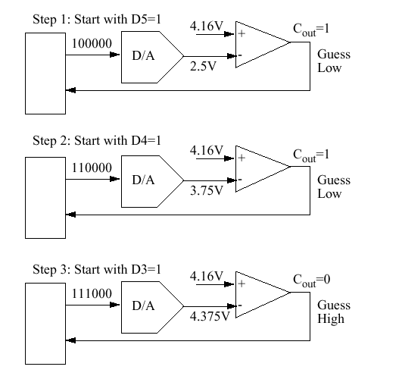
Since the conversion will require a number of steps equal to the number of bits in the resulting number, conversions of higher precision require more time.

Case Studies Using A/D Converters
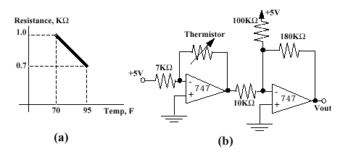
Question: What is the output voltage for the circuit on the right at 70 degrees Fahrenheit?
For the following photocell circuit, choose the resistance values to deliver a 0V offset and a 5V span for the range of 2-10 lumens.

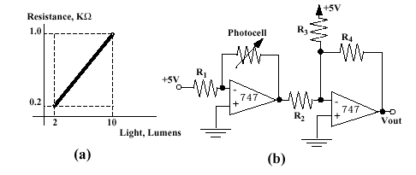
For the following robotic arm, write a subroutine that will sense the position of each potentiometer used to determine the position of the arm’s axes. Each potentiometer is sent through an amplifier that converts it to a 0V-5V signal, and you should store
the four values on the bottom four locations of page zero.
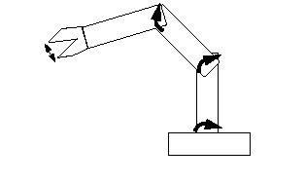
Write a program that will increment the value output on Port B once every second.
Write a program that will calculate the duty cycle of an input wave, and store the result at locations $0000-$0001. Assume neither the high nor the low period of the signal is greater than 30msec or less than 50msec.

Example:
Servomotors are controlled by pulse width modulation signals. An input of 1msec high over a 20msec period will turn the motor all the way counterclockwise, while an input of 2msec high over a 20msec period will turn the motor all the way clockwise. Write a program that will continually turn the motor from all the way CCW to all the way CW over a period of 1 second.

1. Asynchronous Communication:
In an asynchronous communications system, the two devices communicating use the same clock frequency, but may have different phases. This makes communication more difficult, but it reduces the complexity of the interfacing hardware. In an asynchronous serial communications system, for example, only two wires need to be connected between the two devices; one for the serial data line, and the other for signal ground. Sharing the same clock with the same phase would require the
use of a third line to transmit the clock.
Question: What is an application in which asynchronous communication (same clock frequency, different phase) is better than synchronous communication (using the same clock)?

In order to account for the fact that the two computers being used may have different clock phases, it is necessary to use “start” and “stop” bits to frame the data being transmitted. A high signal is considered to be idle, and a single low pulse (the start bit) tells the receiver to expect data to begin arriving. Data is then transmitted with the LSB first, and each of the bits is sent in sequence, one per clock cycle. After the data bits have been sent, a parity bit is often sent. The parity bit is useful to help recognize when a transmission error has occurred. If this happens, the byte will be retransmitted.
Parity can be either even or odd, which means that the parity bit is set in such a way that the total number of ones in the data bits and the parity bit combined equals an even or an odd number.
For example, a data byte of %01100111 with even parity would have a parity bit of 1 to bring the total number of ones sent to six (an even number). The same data byte sent with odd parity would have a parity bit of 0, keeping the number of ones at 5, an
odd number.
Question: If the hex number $45 is being transmitted with even
parity, what is the value of the parity bit?
When the entire data byte has been transmitted (with or without parity), two stop bits (high voltage) are transmitted to allow the receiver to recognize that the first transmission is now complete.
The transmission of the next byte will begin with another low start bit to warn the receiver that more data is arriving.

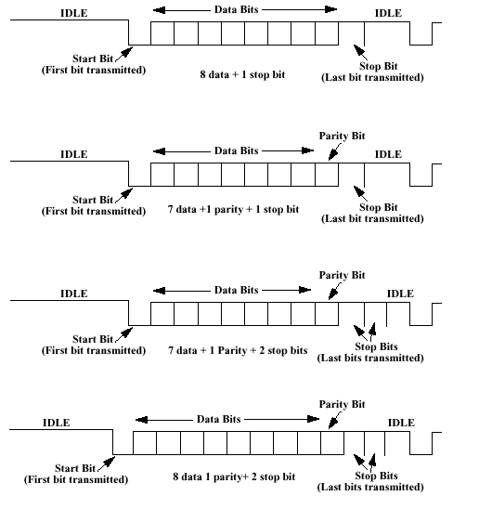
Question: In what circumstance would we want to send seven bits instead of eight?
Serial data speed is the number of data bits transmitted per second (BPS). Baud rate is the total number of all bits transmitted, including parity and framing bits. Thus, baud rate is always greater than the data bit rate.
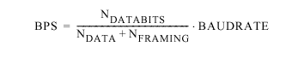
Since each frame contains a certain number of framing bits (start, stop, parity) and a single character (typically ASCII code), we can also determine the number of characters per second being transmitted over the interface.
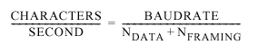

Question: If a serial communications link has been established with 7 data bits, 1 parity, 1 start, and 1 stop with a baud rate of 1KBaud, how many BPS are being transmitted? How many CPS?

The RS-232 standard uses +12 volts to transmit a logic 0, and a -12 V to transmit a logic 1. Since these signals differ from the standard TTL and CMOS levels, the MCU must use a charge pump similar to the one on the EEPROM programmer to create
the appropriate charge, or use a special buffer chip to create the appropriate signal levels.

Introduction to the SPI Subsystem
In the asynchronous serial subsystem, communication between two devices used the same clock frequency, but the two clocks could have different phases. This was because the clocks were each generated internally by the two devices, removing the need to send a clock along with the data. Such an asynchronous communication link is ideal for transmission of data over long distances, since it minimizes the
hardware costs required by the addition of an additional wire. However, communication over short distances would benefit from the use of a common clock signal, and the added hardware cost would be minimal if the transmission took place over a distance of a few meters. The addition of a common clock signal to be transmitted along with the data makes a serial communications link synchronous.
Synchronous serial communication is commonly used when interfacing microcontrollers with peripheral hardware such as printers, so it is referred to as the serial peripheral interface (SPI).
The SPI subsystem can transmit and receive data at the same time, so it requires two data lines (MISO and MOSI). The addition of the SCK line is required for synchronous communications, and the SS line determines which slave device is selected to communicate with the master. If the device is configured as a master, it will use the MOSI line for output and the MISO line for input. The SCK line will also
be an output for the internally generated clock signal. If the system is configured as a slave, it will use the MISO line as an output and the MOSI line as an input, accepting the clock signal and slave select lines from the master as inputs. Data is written and read at the same time by both the master and the slave. As the master sends out data, it also reads the data that is being sent by the slave, so data transmission is in a loop.

Stepper Motor Control
Stepper motors are one of the most useful actuators that can be connected to a microcontroller. They allow the computer to precisely control the position of a rotating shaft by sending a series of carefully timed pulses. Unfortunately, stepper motors contain several coils, which means that they are an inductive load. As we have mentioned several times this semester, that means that we must take some
precautions to limit inductive inrush and outrush currents. To provide a level of buffering between the microcontroller and the stepper motor’s coils, the signal will pass through an inverter chip on its way to the motor.This will have the benefit of isolating the MCU from bursts of current, and it will have the added benefit that the 74LS04 chip is designed to deliver more current than the 68HC11 can.
Once the microcontroller signal has passed through the inverter,
it is still too weak to drive the stepper motor. It must pass through a transistor before the current will be great enough to energize the coils of the stepper motor.

